Spring 2019

CALLING ALL Middle School
‘XTREME SUMMER CAMPERS

Summer camp is almost here It is the event you’ve all been waiting for! It’s a time away… At ‘Xtreme 2019 you’ll hear Todd Jones speak, The band Dividing Asunder led by Blake Scolari lead us in worship and laugh as Patrick Weber entertains us.
Here’s what you need to know and do. Please read this completely, some things have changed.

CALIFORNIA REGULATIONS: California has regulations that affect all camps, one of
which requires us to do LICE CHECKS on EVERYONE before we leave for camp. We suggest you check your kids head for lice yourself the week before, so in case you find any lice you can take care of it before camp. If we find lice your child will not be allowed to go to camp.
Please arrive at church at 12:30P with your HAIR WASHED and DRIED that morning. NO HAIR PRODUCTS!!!! Lice checks will be done first beginning at 12:30P. Go directly to the chairs for HAIR checks, then once you have been cleared you will need to get ‘checked-off’ as having a LICE check, then check in at registration table and get your room and bus assignment.

SONOMA CANOPY TOURS: Alliance Redwoods Conference Grounds (ARCG) offers
Sonoma Canopy Tours. The discounted cost for students while at 'Xtreme Camp is $69 (Great Deal). You must fill out the Participant Agreement for Sonoma Canopy Tours and send the signed form with your student with the $69 CASH to be turned in upon arrival at camp.

MEDICATIONS:
ALL MEDICATION MUST BE TURNED IN with the form below in a Ziploc bag at the registration table.
NEW MED INSTRUCTIONS THIS YEAR: See Below Medication slip for instructions.

ROOMING ASSIGNMENTS: Will NOT be changed the week we leave. If you have NOT made any requests they need to be made now. Please contact us ONLY if you have NOT already made requests. Email Laura at LauraR@vc.church or call 925-474-9413 and leave your request.

WHEN & WHERE:
Departure: Saturday, June 22nd. Come to church at 12:30P. Check in at LICE check first, get cleared, then check-in at registration table and get your bus and cabin assignments. Load on the bus at 1:00P. Buses will roll by 1:15P.
Eat before you come or Pack a lunch, we’re not stopping. Dinner’s at 6:00P.
Return: Thursday, June 27th between 3:00-4:00pm (We’ve been very consistent…we can’t estimate closer d/t traffic)

WHO: Everyone who has already signed up & wants to experience all that God has for them this week.

WHAT TO BRING:
- Clothing for a week of fun, nighttime, messy games, & swimming. MODESTY is the policy.
  - Girls must bring a 1 (ONE) PIECE BATHING SUIT or plan to wear a NON WHITE shirt. No spaghetti straps and no skin showing on tummies, no SHORT shorts.
  - Boys no Speedos & no boxers hanging out.
  - White T shirts to be used and stained during REC. Buy a package with a friend.

- Money for kayaking $20 (if offered), snacks and drinks, merchandise from talent & also for the gift shop. They can spend a wad or no money at all. $69 for Sonoma Canopy Tours plus the signed Participant Agreement. Paintball will only be done during REC activity. NO longer a paintball course at camp.
- A Refillable WATER BOTTLE with their name on it.
- A Bible & pen! If you don’t have one, then let us know and we’ll hook you up!
- ONE bag!! That is 1, not 2, not a suitcase & a bag, not two bags & a backpack, ONE bag! You may bring a SMALL carry on backpack. Space is limited.
- A sleeping bag, pillow, & flashlight (optional). Most likely the pillow will go with you to your seat on the bus. Your bag/sleeping bag will go under the bus. To protect your sleeping bag you may want to put it in a plastic bag clearly marked with your name.
- 2 towels, one for bathing and one for swimming.
- Soap, shampoo, toothpaste and brush, deodorant, and anything else you need 2 B clean.
- Any medication that you will need for the week. It will need to be turned in when you check in with the enclosed WHITE form filled out.

WHAT NOT TO BRING:
- Electronic devices.
- SPEAKERS for iPhones or other music devices are not allowed. Your phone with headphones will only be allowed in your cabin or on the bus. They will be confiscated if we see them. We’re going up to experience something outside our normal lives. Let’s leave “normal stuff” here.
- Anything illegal. Substances or weapons of any type. Enough said.
- Bad attitudes. We’re gonna have a blast! So start out on the right foot.
- Valuables, nice clothes, more than 1 bag.

JAKE and LAURA

P.S. If you get motion sickness take something on Saturday before we leave and bring an additional dose for the trip home.
You may send a letter or care package to your child to the address below…remember it takes several days to get there. Plan ahead.

CAMP ADDRESS: A.R.C.G. MS ‘Xtreme Camp, 6250 Bohemian Hwy, Occidental, CA 95465-9107
Phone #: 707-874-3507

‘XTREME SUMMER CAMPMEDICATION FORM
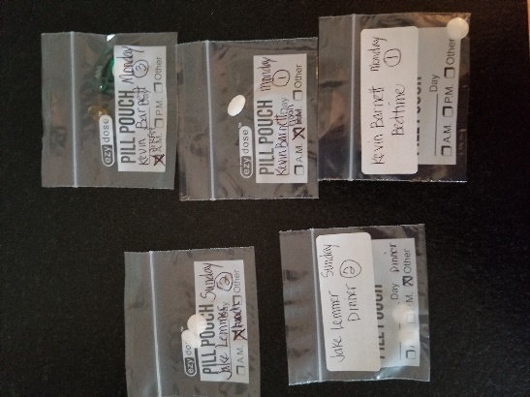
NEW MED INSTRUCTIONS THIS YEAR: Medications will need to be put into individual pill pouches for the times of day that they will be passed out. Medications are passed out at Breakfast, Lunch, Dinner and Bedtime. Pouches can be purchased at Walgreens, RiteAid or online. Be sure to CLEARLY label each pouch with your child’s name, the day (Sun, Mon, etc) and time (Brkfst, Lunch, Dinner, Bedtime) when the pill is to be given and # of pills in the pouch (Top picture). For example, if your child takes one pill each morning and 2 pills at bedtime you will need to prepare one pouch for each breakfast (5) and one pouch for each bedtime (5). You will put a total of 10 pouches in the Ziploc baggie. If your child takes meds at Brkfst, Lunch and Dinner you will then be putting in 15 pouches—five for each meal into the Ziploc. Please use a ball point pen…a sharpie or felt tip will smear (Bottom picture). You can also add an address label to the pouch and write on that. (Top picture).
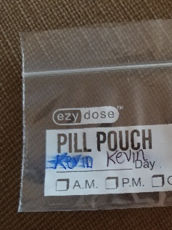
All the medications you are preparing should be listed on this medication form and placed in the Ziploc bag along with all the individual pouches. Please WRITE YOUR CHILD’S COUNSELOR AND CABIN on the form when you arrive at church and get the cabin assignments. Be sure to SIGN THE FORM before placing it in the bag. Please note the OTC medication list below. Do not send any of these medications to camp as they will be provided if needed. Only send OTC meds that you will be putting in the pouches to be taken at a scheduled time. If your child needs meds to be refrigerated or has liquid meds we can still take care of that. The child can have All EPI PENS and INHALERS with them or their counselor.
(Please note that if you are sending more than one child to camp on medications, they need to each have their own form and separate Ziploc bag.)

As the parent/guardian of the child listed below I have prepared my child’s medications in the enclosed pouches to be given to my child at the labeled days and times. The medications, dosages and times are listed below. I understand that the medications as packaged and labeled will be given to my child and are my responsibility. The medic will provide any over the counter meds as needed.

__________________________________________ _______________________________________________
PRINT NAME OF PARENT OR GUARDIAN SIGNATURE OF PARENT OR GUARDIAN

CAMPER’S NAME:____________________________________________________________________________

COUNSELOR: _________________________________________ CABIN:________________________________

NAME OF MEDICATION | DOSAGE | TIME: Brkfst, Lunch, Dinner, Bedtime | REASON FOR MEDICATION

Alliance Redwoods Conference Grounds

O.T.C. Medication List

- IBUPROFEN 200MG TABLETS
- ACETOMINOPHEN 80mg, 325mg, 500mg TABLETS
- ACETOMINOPHEN LIQUID 160mg/5ml
- ACETOMINOPHEN CHEWABLE 80MG
- MIDOL
- COLD RELIEF TABLES (Multi-symptom)
- MEDI-SELTZER
- MILK OF MAGNESIA
- COUGH DROPS
- COUGH SYRUP
- CLARITIN 10mg
- BENADRYL 25mg & 50mg
- PEPTO-BISMOL
- BISMUTH TABLETS
- ANTACID TABLETS
- ORASOL GEL
- LIP OINTMENT
- CALAGEL (Itch Relief)
- HYDROCORTISONE CREAM
- TECHNU POISON OAK WASH
- TRIPLE ANTIBIOTIC OINTMENT
- ICY HOT CREAM

